**VECTR v5.7.0 Feature Breakdown**

Table of Contents

Added support for Subtechniques in Heatmap 2

Label configuration in Heatmap 4

Added ability to identify isolated Test Cases when Assessment Kill Chain is changed 6

# Added support for Subtechniques in Heatmap

What is it?

Subtechniques now show up in the Heatmap. Any existing datasets that use “legacy” techniques will be automatically mapped to subtechniques using the [mitre-crosswalk](https://attack.mitre.org/docs/subtechniques/subtechniques-crosswalk.json).

How does it work?

Navigate to the Heatmap reporting screen. You will see something like this:

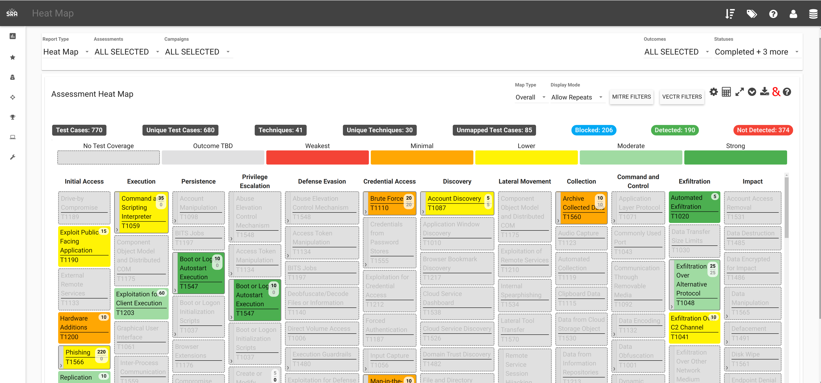

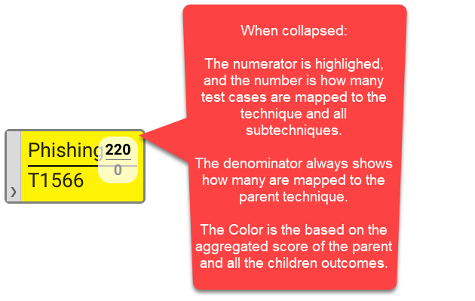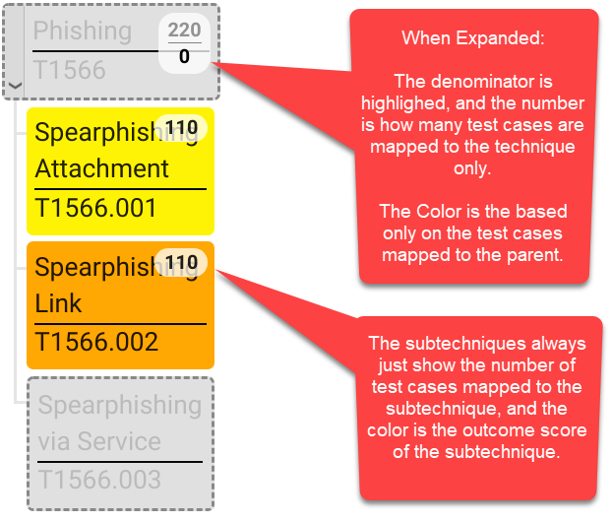

How can this feature help me?

This will allow users to map test cases to subtechniques and visualize outcomes

**Additional Comments:**

When there is a scenario where a legacy mitre id can map to multiple subtechniques, we take the first item in the list of the crosswalk file. For example, if a test case was mapped to mitre id T1034, it will now be mapped to T1574.007.

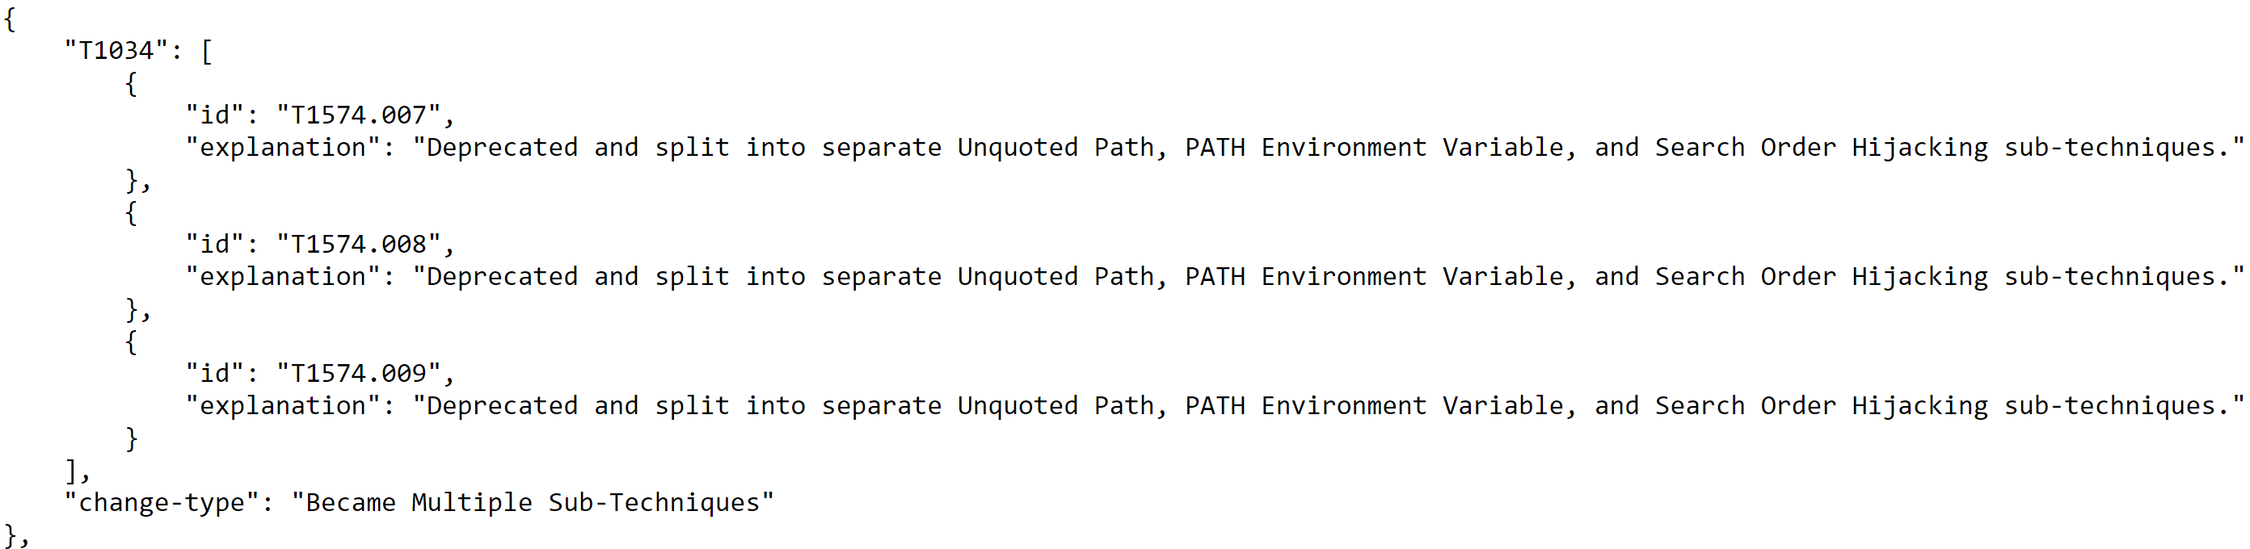

There are some cases where legacy ids have been deprecated:

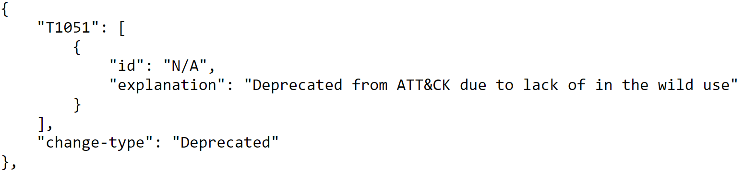

These will show up in the Data Integrity screen as “MITRE ID UNRECOGNIZED”



# Label configuration in Heatmap

What is it?

Allow for some customization of the labels that show up on the Heatmap.

How does it work?

Click the cog in the top right of the Heatmap:

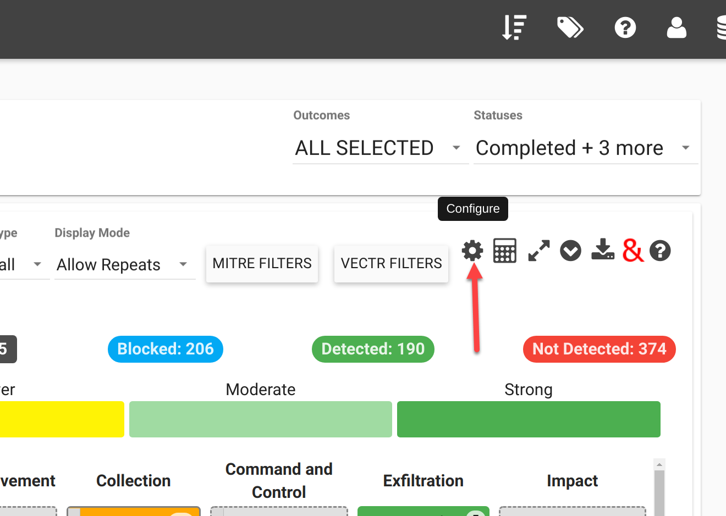

This will bring up the label config widget:

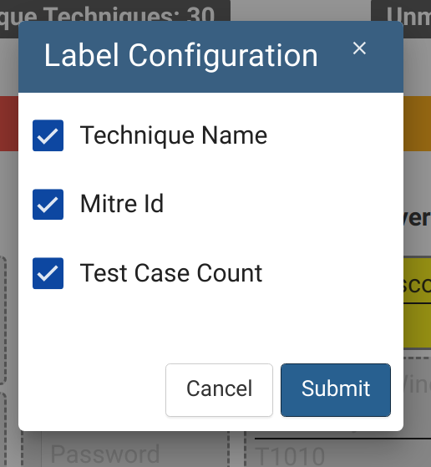

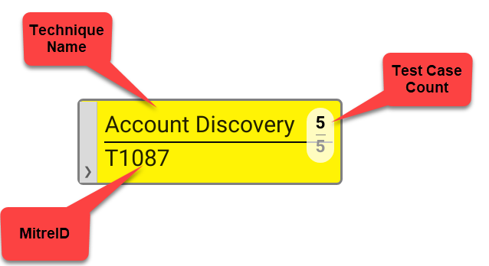

How can this feature help me?

This will allow for screenshots or visuals to be customized.

# Added ability to identify isolated Test Cases when Assessment Kill Chain is changed

What is it?

Test Cases that are used in a Campaign but are not mapped to the Assessment Kill Chain are now displayed in a warning screen when the Assessment Kill Chain is changed, and also show up in the Data Integrity reporting screen.

How does it work?

Here’s an example of a campaign with 3 Test Cases mapped to Exfiltration

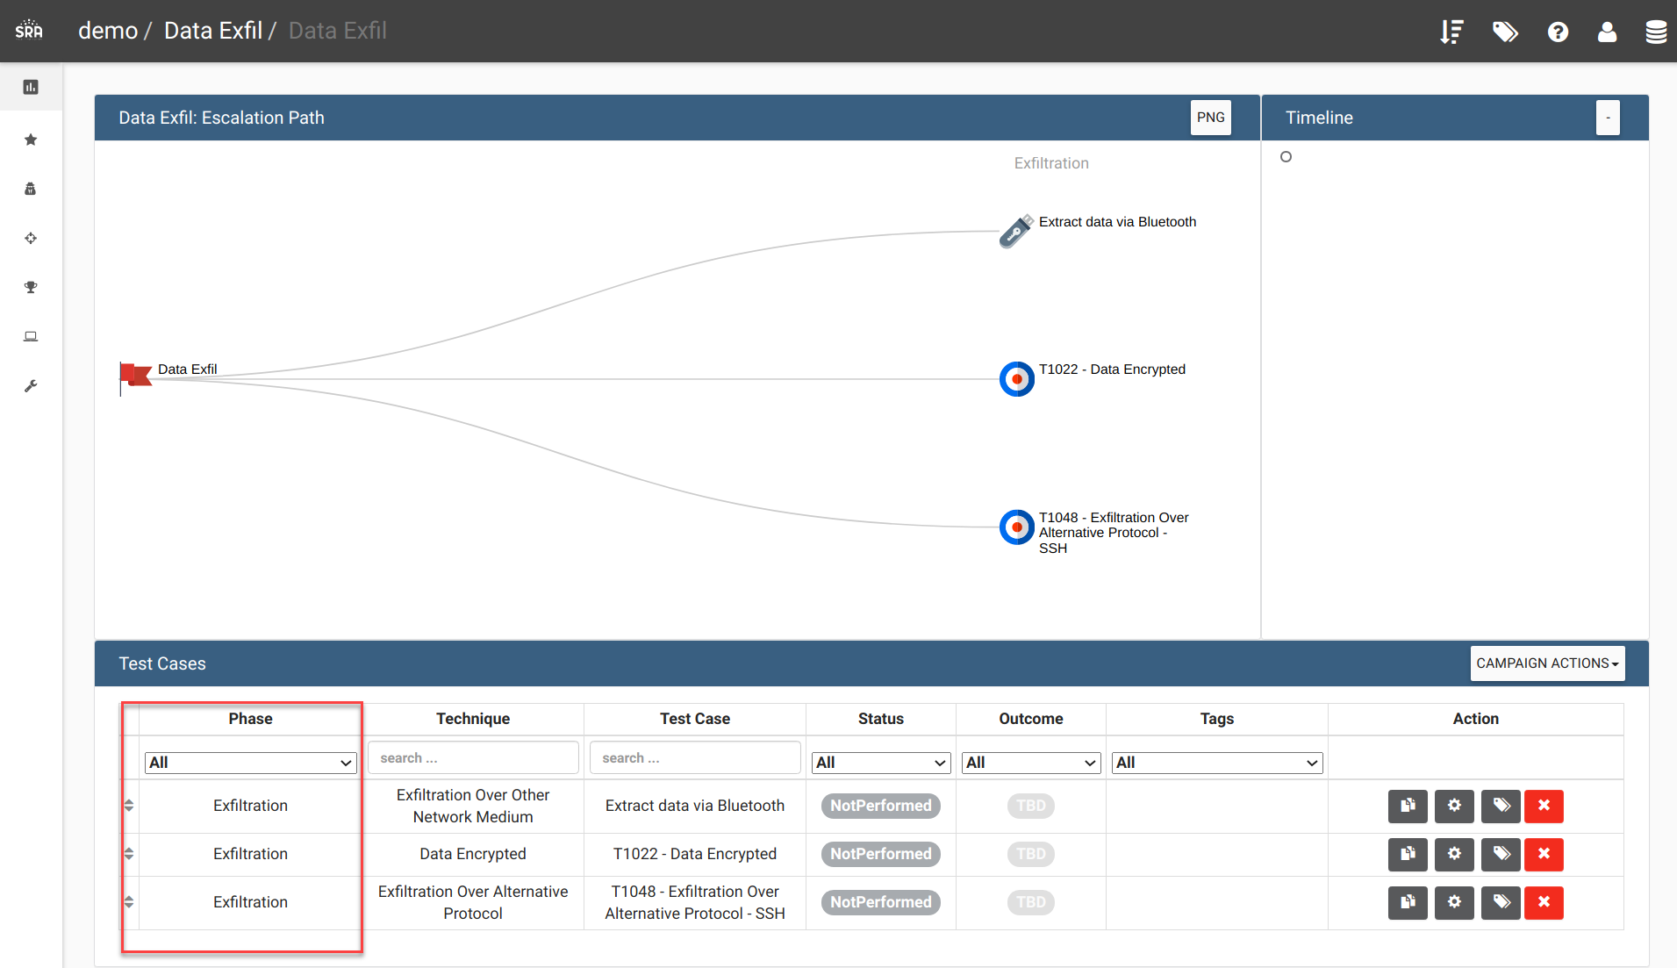

Create a Kill Chain without Exfiltration as a Phase:

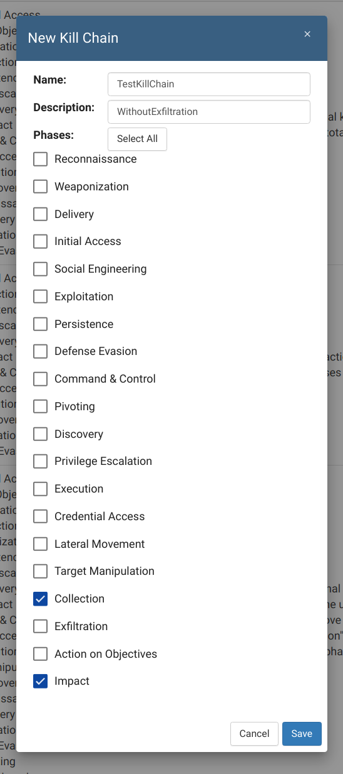

Edit the Assessment to use the new Kill Chain:

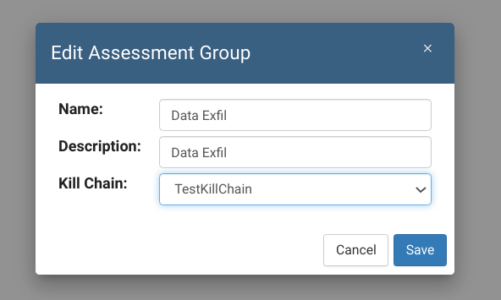

This will show a conflict report:

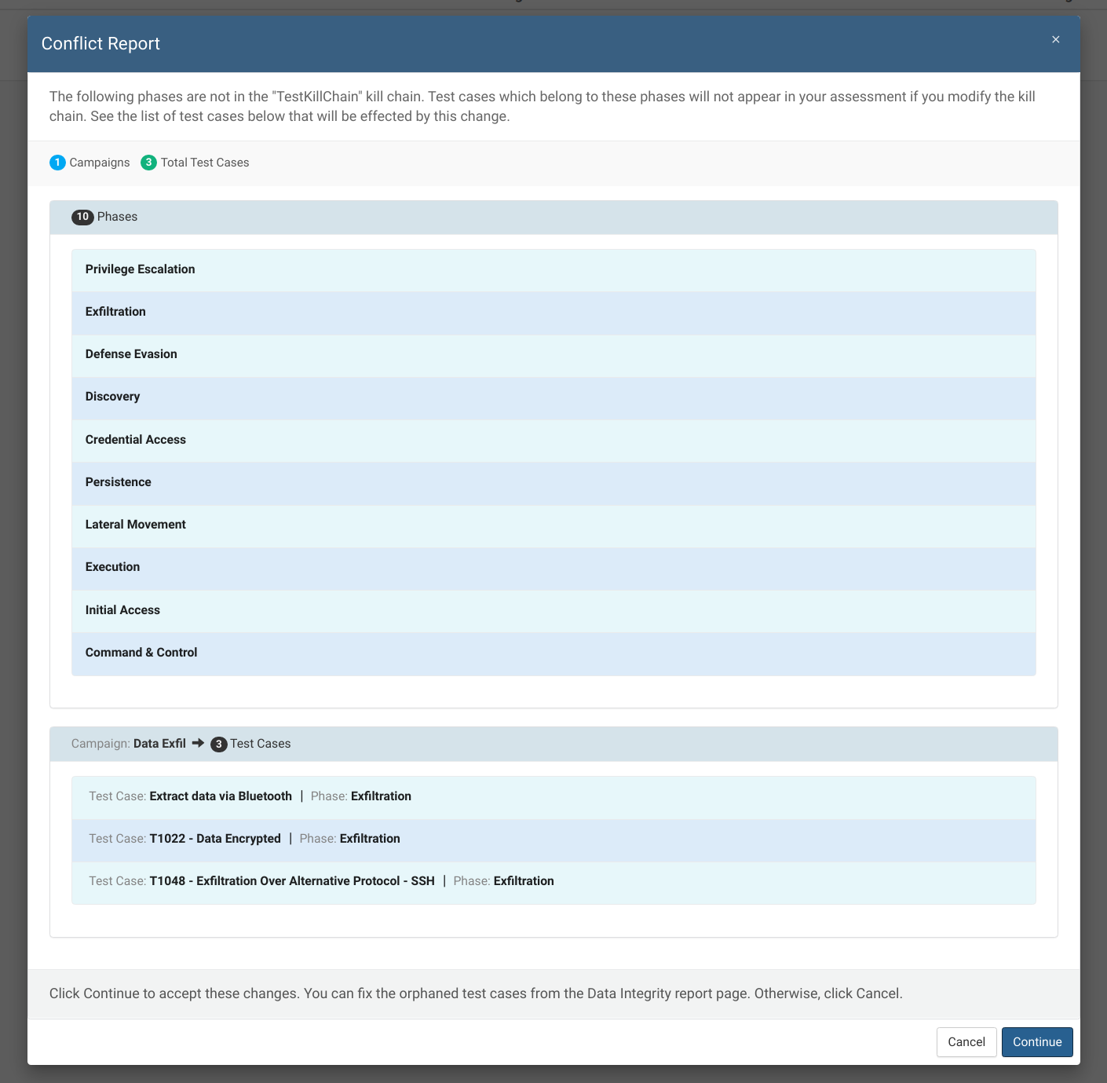

The Campaign will now not show the Test Cases:

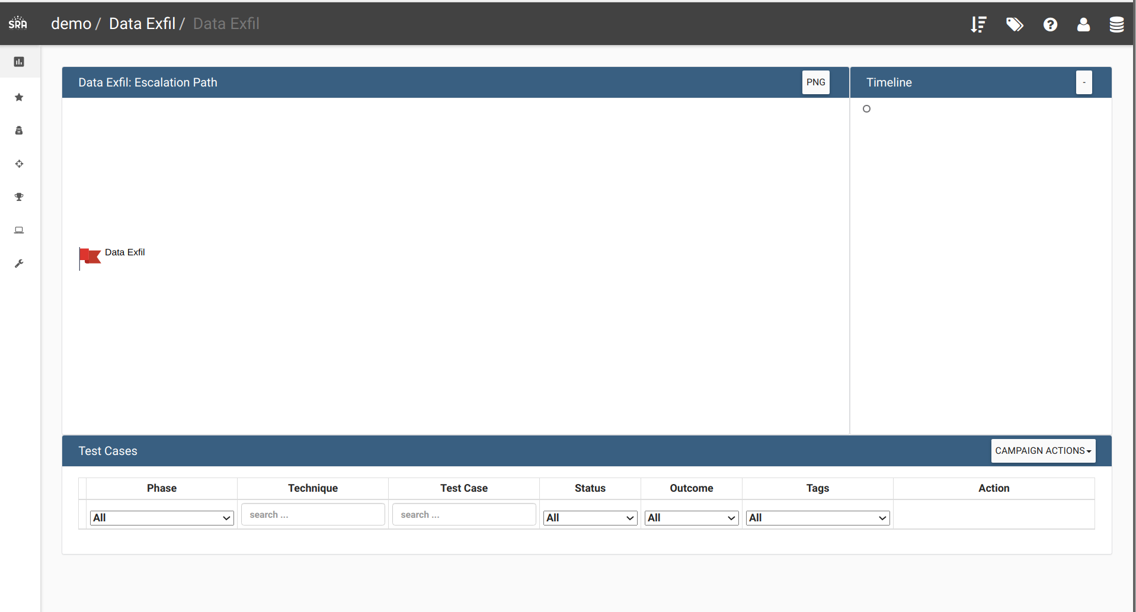

You can go to the Data Integrity report to fix the issues:

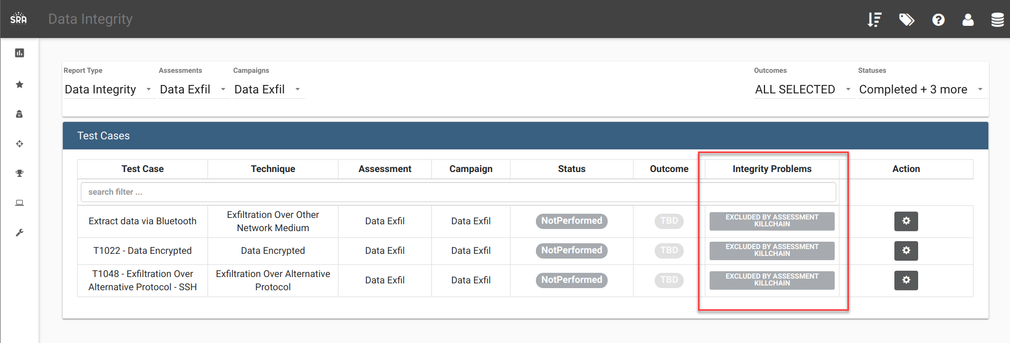

How can this feature help me?

This will allow users to not “lose” data when changing a Kill Chain.